This assignment was made more difficult than it needed to be by jumping head first into it without looking at the functions that were provided but there were still problems nonetheless. The purpose of it was to understand how functions worked in C++ and the goal was to design a simple text based game from functions that were provided to us. The program inputs consist on which direction the user would to go whether it be up, down, left, or right using the W,A,S,D keys on the keyboard and yes or no answers using the y and n keys, respectively. For the movement keys the program will recursively call another function with each room being its own function. Error handling was taken care of by using while loop statements.

This program was made 10 times more difficult because I did not know at first that a function for movement was provided to us in code that was given so all movements were handled at a per function basis instead of just calling that one function to take care of it. Once the function was used instead of hand writing the code over and over again, movement of this program was handled using the WASD keys on the keyboard, W for North, A for East, S for South, and D for West. Each time the program asks the user which way they would like to go and the user would press the desired key the function would recursively call another function. In hindsight, this was not the best choice because sometimes for some reason even though a key would be mapped to call a specific function it would call another one or other times it would work just fine. At first this was thought to be a problem with Windows but the Linux server gave me the same results. So far this has only been tested when the function would call Room5 but instead go to Exit.

Sample code was given at the beginning of the assignment so as to make it easier so we didn’t have to hand write all the functions and each game had a uniform style to them. In the sample code there were functions for fighting monsters, eating food, finding treasure, and four rooms were designed for us. Our job was to implement these functions and add four more rooms. Development time for this assignment took the full two weeks.

In testing the program, I found that sometimes the line of code that would force the users input to a capital letter if the user input was a lowercase letter would cause the program to crash except from the function that was provided to us. Also, when a user would call the function for Room5 while inside the Room 5 function the program would instead call the Exit function but other than that everything worked as expected. Below is a sample of the output from within Room5 and a picture of the code used.

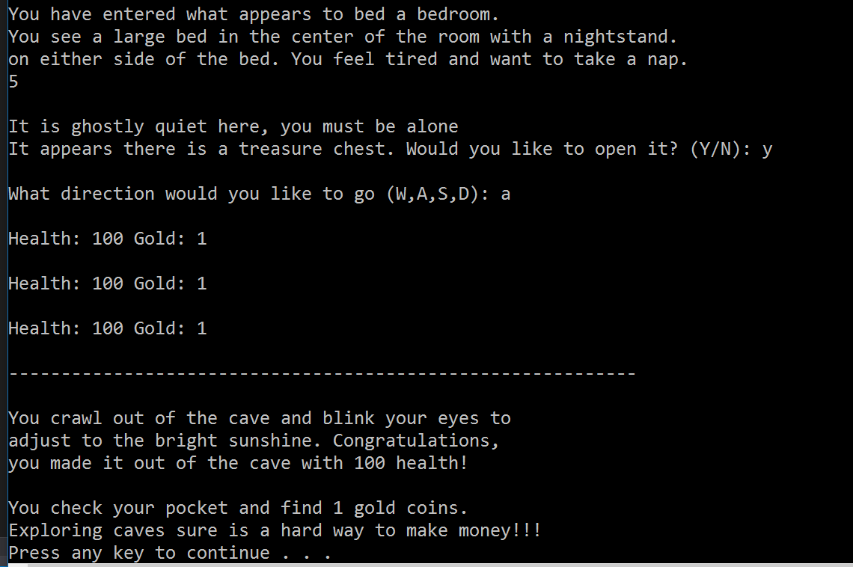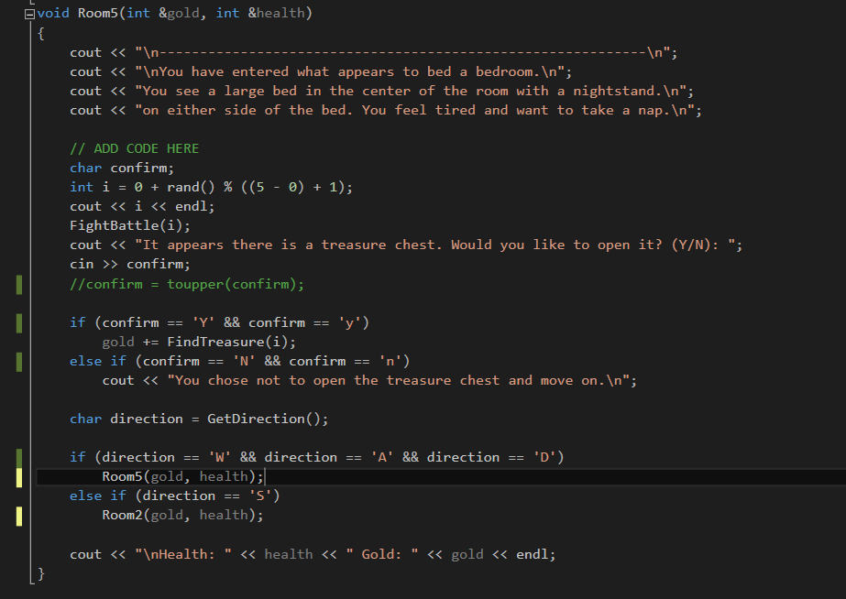

Even though this program was a bit overwhelming due to how frustrating recursively calling functions is it is still labeled a success. If this assignment were given again I would not go about recursively calling all the functions.